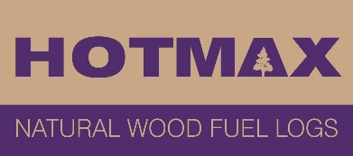
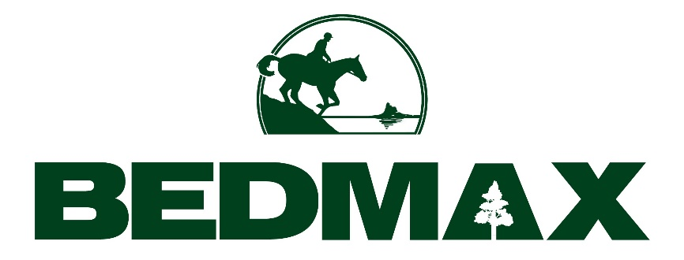
How We Make Hotmax
100% natural wood, sourced from British forests.

Hotmax is made from compacted, natural, unadulterated, recycled softwood dust and particles, a by product created during the manufacturing process of our horse bedding Bedmax shavings.

There are no additives in Hotmax whatsoever. All the timber we use in our production processes is sourced from sustainably managed British forestry.

For every tree that is cut down as part of the production process, another is planted, re-capturing carbon out of the atmosphere as a natural part of the production cycle.
As Hotmax is made from freshly cut pine trees it does not contain preservatives or other chemicals.

-ENDS-

