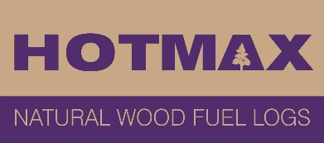
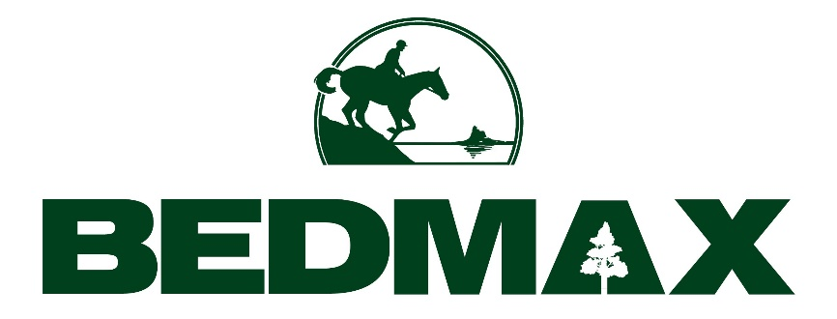
Why is wood not the best fuel for your firepit or wood burner?

When you think about what logs for your firepit or stove, you’re probably not alone in assuming firewood is the best option.

However, you could be doing your lungs, pocket and stove some damage over the long term if you choose to keep using traditional fuels like wood, usually with a high moisture content.

Freshly cut wood can have a water content between 60% and 80% which means that when it is used in a stove, it is almost like trying to burn water. The best wood for log burners or chimineas is actually fuel that has a low moisture content and has high heat generation.

This is because burning wet wood produces excess smoke and emissions, and ultimately generates less heat. It also leads to an inevitable blackening of the stove glass and a build-up of soot in the chimney – with significant maintenance costs further down the line.

Hotmax wood dust alternative fire logs have a moisture content of only 7%, making it ideal to be used in any wood-burner or multi-fuel stove. This is because it is high heat producing and longer lasting, saving you a penny or two and keeping you warm around the fire throughout the summer under the stars or long winter nights.

Unlike Hotmax, seasoned wood is less reliable and harder to light. So, you’ll be doing yourself a favour by selecting fuels like Hotmax. This means that logs can be lighted immediately and without any stress.

Thinking about health, the best fuel for a firepit are logs that are spark free and smokeless. With this in mind, the next time you think about which logs to throw on your fire, try the Hotmax wood briquettes which offer a higher quality, energy efficient and safer alternative.

-ENDS-

