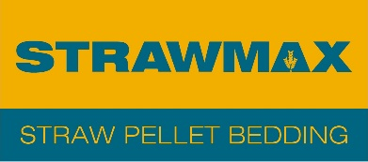
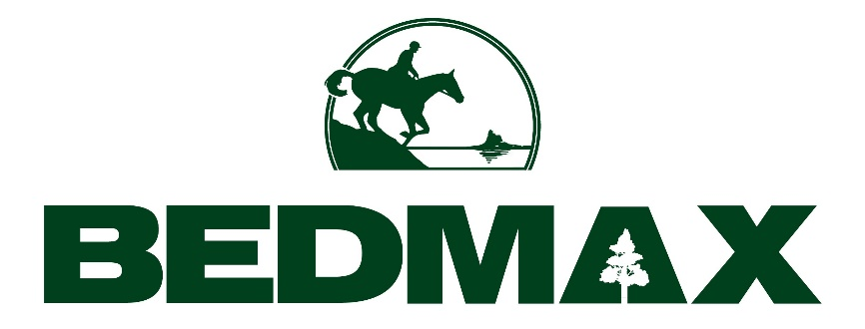
Will my horse eat straw pellet bedding?

Horse owners often ask us if their horse will eat straw pellets intended as bedding. The quick answer is yes, if your horse is hungry it might try, but watering is the key.

In the past, when most horses were bedded on loose straw, eating the bedding was a problem for owners who were trying their best to control their horses’ diet. Stabled horses could plough through their forage and move seamlessly onto their straw bedding, and greedy horses could gain a lot of weight. So what happens when you put Strawmax straw pellets on the floor of your horse’s stable?

There’s no doubt from our experience that if you horse is hungry it will try them. After all, they are pure, unadulterated high quality straw. But so far owners using Strawmax are reporting that very few horses will eat them, and even those that do quickly find that crushed straw pellets become considerably less appetising.

A much more important deterrent is moisture. We actually recommend that the best way to use Strawmax straw pellets is to soak the pellets in water in the stable – you can find out more about how to soak Strawmax straw pellets here. This very quickly ‘fluffs’ the pellets up to about 3 times their dry volume, forming a much deeper and more supportive bed.

The capacity of straw pellets to absorb water is so great that watering them first does not reduce their effectiveness in soaking up urine at all, and we definitely recommend this as the solution to stop your horses from eating its bedding. In other words, if you have a horse that’s keen enough to try its bedding, then soaking your Strawmax pellets is the easy and effective way to prevent it.

Going back to the point about the content of Strawmax straw pellets, they really are made from good quality fully traceable wheat straw, pure and simple. With absolutely no additives whatsoever, the straw is chopped, dried, dust extracted and then pressurised it into pellets.

So if your horse does fancy a straw pellet snack, eating Strawmax will do them no harm at all. What’s more, like all our beddings, our Strawmax production process has been audited to give you the BETA NOPS Bedding assurance that every aspect of production is rigorously managed to prevent the risk of contamination by a naturally occurring prohibited substance (NOPS) that could cause you to fail a doping test. You can read more about our NOPS accreditation here.

-ENDS-

